# Importing into Twitter_2017

Initially, all raw files I stored them under /home/ra2/twitter_tables. I then ran a Python script that generated fixed_Twitter_20*.csv files, which fixed issues such as removing backslashes (\), extra new lines, and others.

Recently, I discovered that I also needed to replace single quotes and commas with spaces, and I removed the '\x00' character as well. After applying these additional fixes, I created a new set of files named cleaned_fixed_Twitter_20*.csv.

I then split each cleaned_fixed_Twitter_20*.csv file into smaller chunks, each with a maximum of 10 million lines, and stored them in separate directories. For example, /home/ra2/twitter_tables/Twitter_2017 contains the chunks for Twitter_2017. I will follow the same process for the remaining files.

Splitting the file into 4 chunks, of max 10 mil lines. Kept the chunk files under /home/ra2/twitter_tables/Twitter_2017

The 3 extra lines across the 4 chunks are the headers that were added to each chunk. The first chunk already had a header, so in total, only *number of chunks – 1* extra header lines were added.

Importing chunk 1

Importing chunk 2

Importing chunk 3

Importing chunk 4

## Issuing the query

**select 'AFL' AS AFL, screen_name4, COUNT(*) AS numConnections from Twitter_2017 where screen_name4 <> 'AFL' and tweet_text like '%AFL%' group by screen_name4;**

The response is right away.

# Importing into Twitter_2018

Created chunks

Importing chunk 1

Importing chunk 2

Importing chunk 3

Importing chunk 4

Importing chunk 5

Importing chunk 6

## Issuing the query

**select 'AFL' AS AFL, screen_name4, COUNT(*) AS numConnections from Twitter_2018 where screen_name4 <> 'AFL' and tweet_text like '%AFL%' group by screen_name4;**

The response is right away.

# Importing into Twitter_2019

Created chunks

Importing chunk 1

Importing chunk 2

Importing chunk 3

Importing chunk 4

Importing chunk 5

Importing chunk 6

## Issuing the query

**select 'AFL' AS AFL, screen_name4, COUNT(*) AS numConnections from Twitter_2019 where screen_name4 <> 'AFL' and tweet_text like '%AFL%' group by screen_name4;**

The response is right away.

# Importing into Twitter_2020

Created chunks

Importing chunk 1

Importing chunk 2

Importing chunk 3

Importing chunk 4

Importing chunk 5

Importing chunk 6

Importing chunk 7

Importing chunk 8

## Issuing the query

**select 'AFL' AS AFL, screen_name4, COUNT(*) AS numConnections from Twitter_2020 where screen_name4 <> 'AFL' and tweet_text like '%AFL%' group by screen_name4;**

The response is right away.

# Importing into Twitter_2021

Importing chunks

First chunk includes only header, so there is not data in it.

# Importing into Twitter_2022

Created chunks

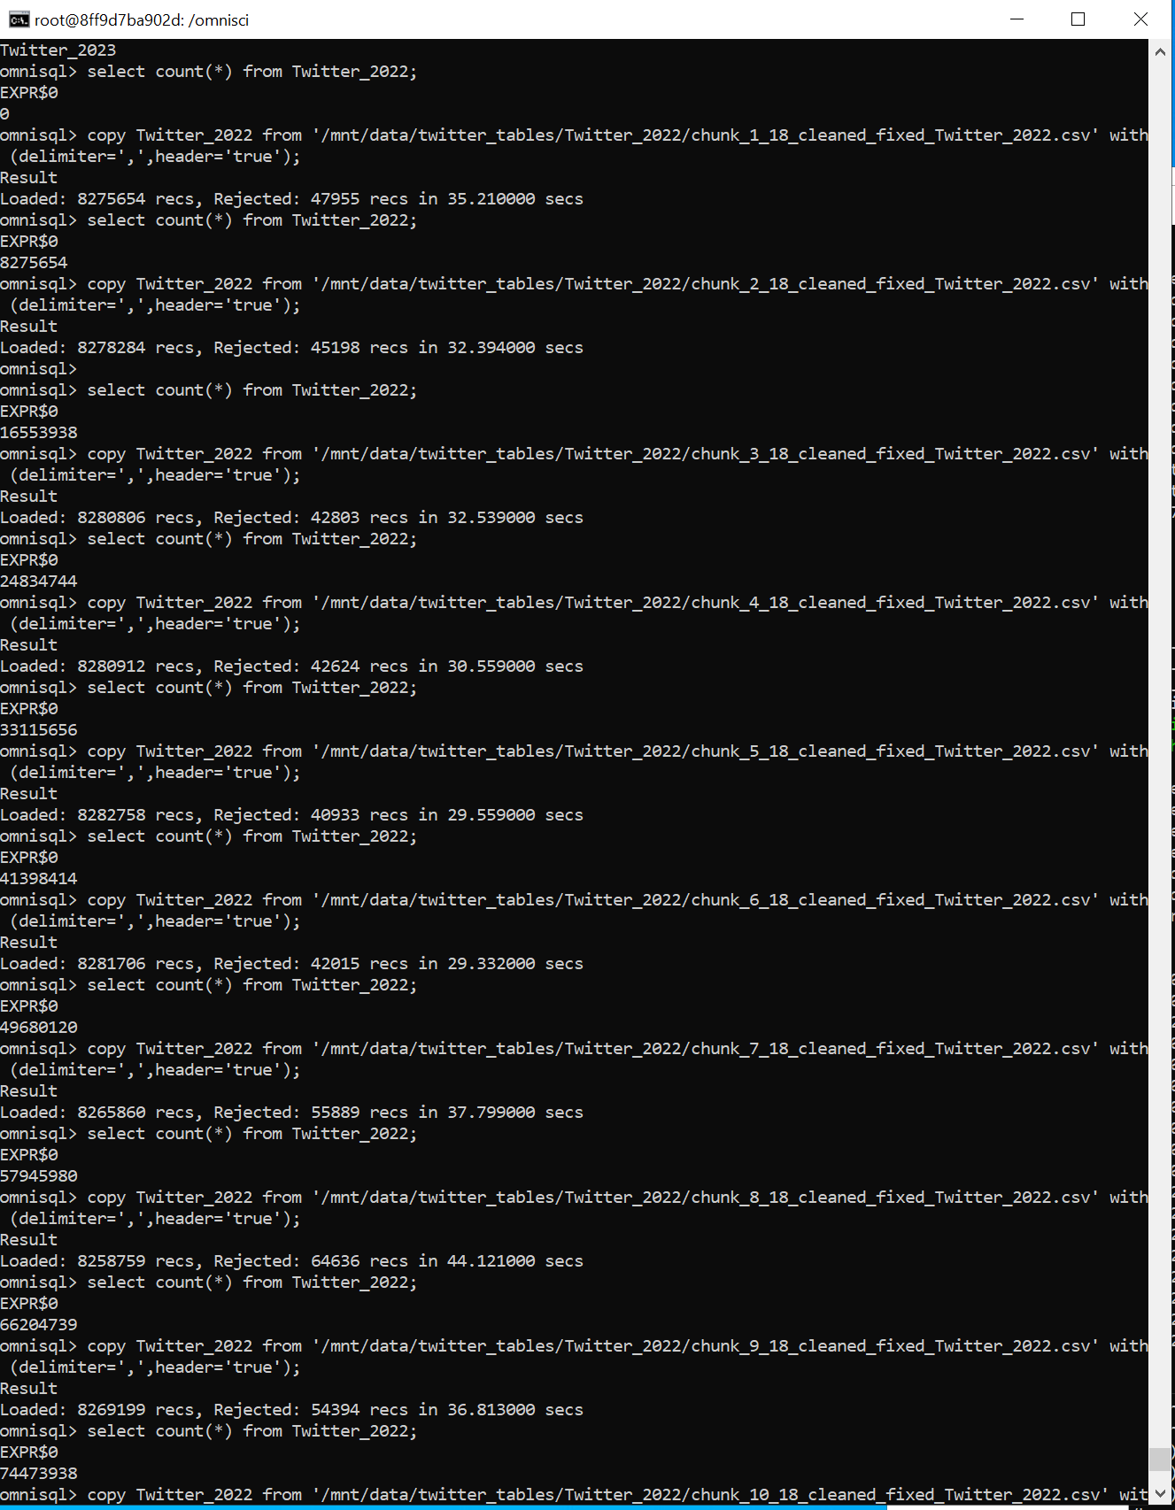

# Importing Twitter_2023

